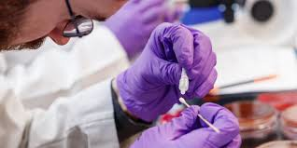

MWRI CLINICAL TRAINEE RESEARCH AWARD

**Three** Applicants will be Funded for One Year With a Maximum of **$5,000** Each

Magee-Womens Hospital residents and clinical fellows are eligible to apply. This award was established to promote education, develop research performance, and enhance the research program of MWRI. It is made possible by the generosity of philanthropic donors through Magee-Womens Foundation.

# TIMELINE

Application Deadline: **October 3, 2025**

Award Term: **January 1, 2026 –**

# December 31, 2026

Please find the application [here](CTRA-Application-2025-Fall.docx). For more information, contact program coordinator Katie Chiappa at chiappac@upmc.edu.